Securing your proxmox access
Add TOTP
Click on Datacenter > two-factor > Add > TOTP
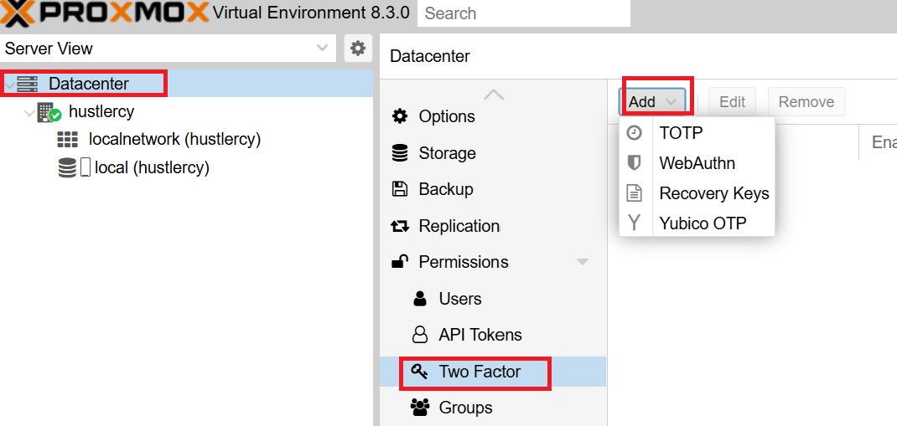
Scan the QR code shown using your MS Authenticator app > add work or school account > scan a qr code
Enter the 6 digit shown

